**Problem 1 : Sample Webpage**

## AIM:

1. Create and design a sample web page using basic HTML tags.

## PROGRAM CODE:

|  |  |
| --- | --- |
| Mywebpage.html | <html><head><title>my page</title></head><body><div><center><h1><u>welcome to my page</u></h1></center><style> body {background-color:#808080; } </style><div class="topnav"><a class="active" href="#home">Home</a><a href="C:\Users\New\Desktop\New folder\education.html">Contacts</a><a href="C:/Users/New/Desktop/New%20folder/education1.html"> EDUCATION</a>><a href="C:/Users/New/Desktop/New%20folder/about.html">About</a></div><div style="padding-left:100px"><div style="padding-top:60px"><img src="C:\Users\New\Desktop\New folder\smiley.jpg" width="150" height="auto" style="float:left"></div></div><p> My name is Rahul Ramakrishnan.</p><p>This is my website.You can find my informations by clicking in the navigation bars.</p></head></body></html> |
| Education1.html | <html><head><title>Education</title></head><body><style> body {background-color:#A75442 ; } </style><h1> Educational Details</h1><div style="padding-left:100px"><div style="padding-top:100px"><div> school: qwerty HSS school. </div><div> marks: 80% </div><div> contact: 0484 2233445 </div><div style="padding-top:100px"></div><div> college:TKM college of engineering,kollam</div><div> marks: 80% </div><div> contact: 0484 2233445 </div></div></body></html> |
| about.html | <html><head><title>about</title</head><body><style> body {background-color:#A75442 ; } </style><h1> About</h1><div style="padding-left:100px"><div style="padding-top:100px"><div> Name: Rahul Ramakrishnan </div><div> ADDRESS: kottayil (h),marampilly po, aluva 5, Ernakulam</div><div> contact: 0484 2233445 </div></div></body></html> |

## RESULT

## We can create a webpage inside another web page using html.

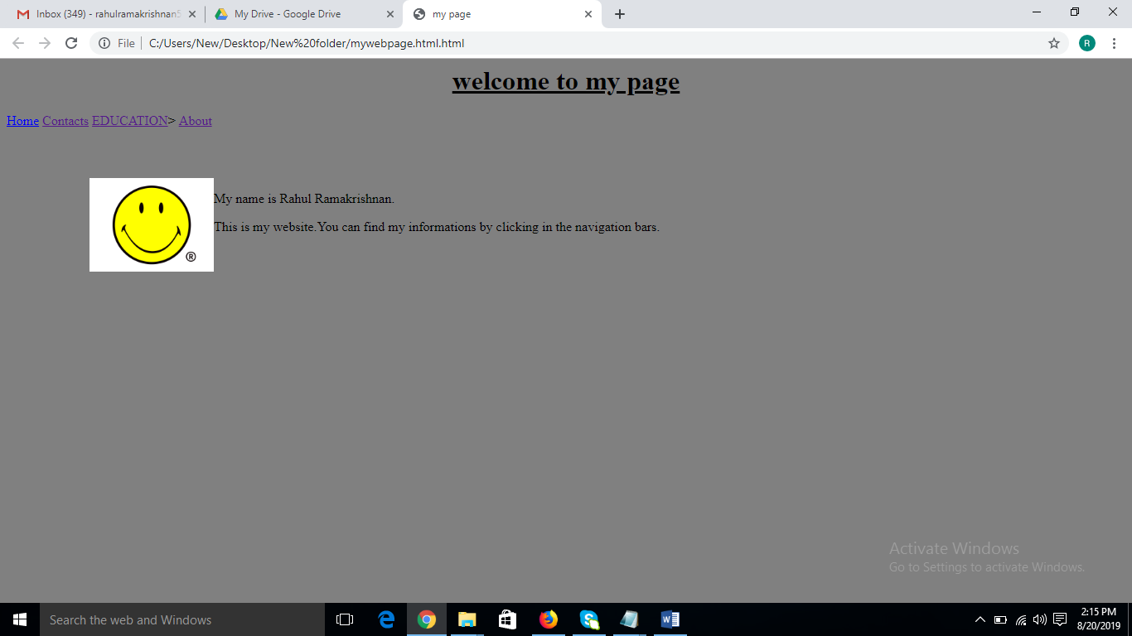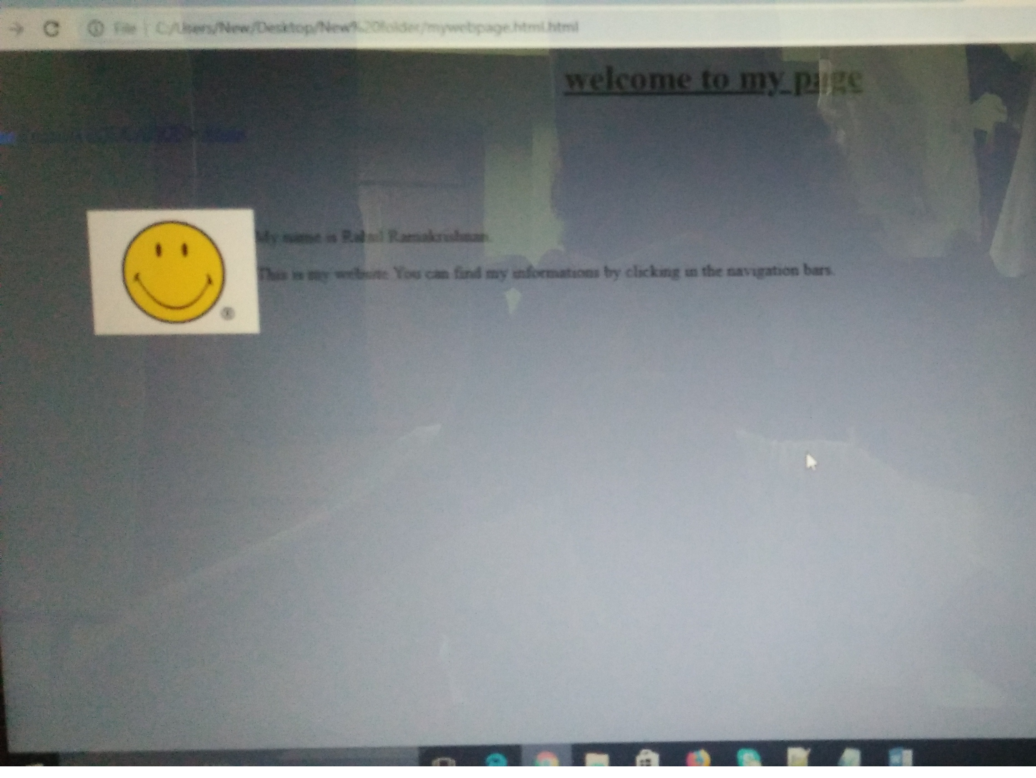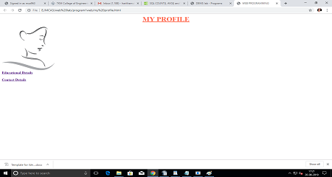

## 

## Figure 1: Home page(My profile)

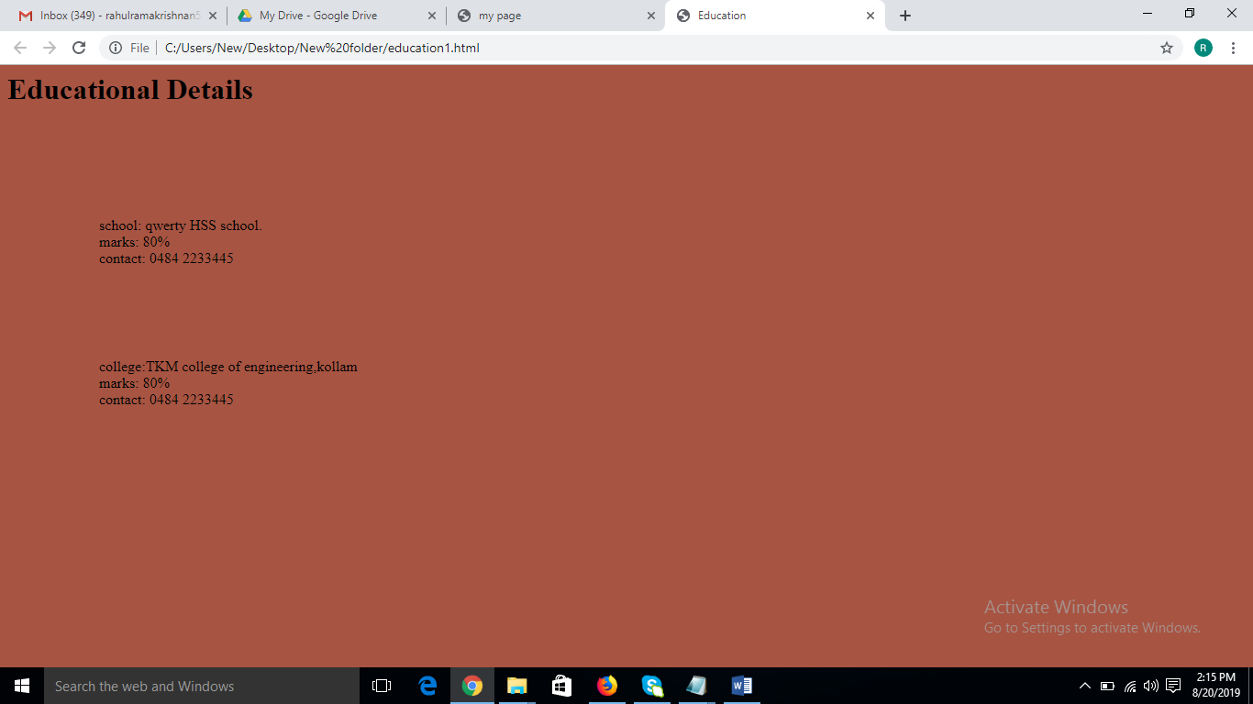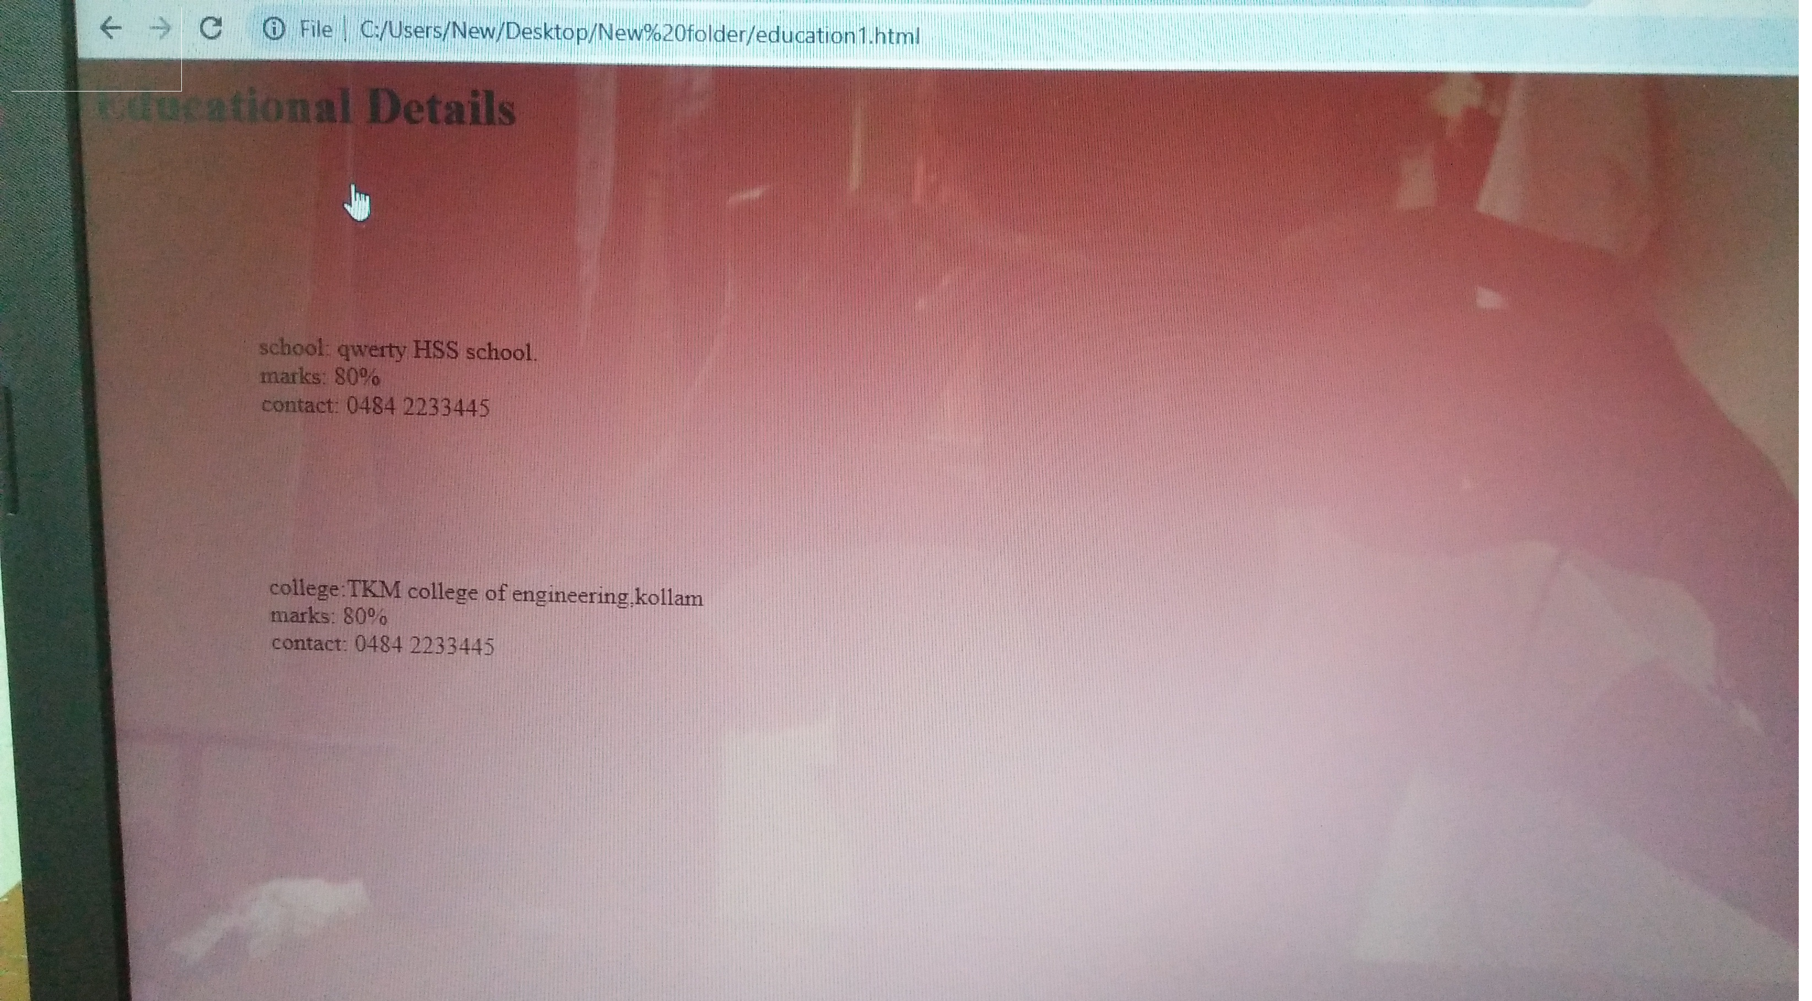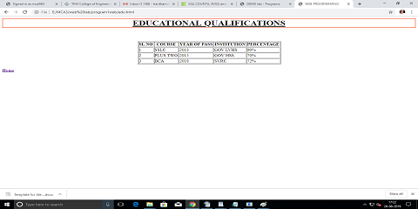

## Figure 2: Educational Details

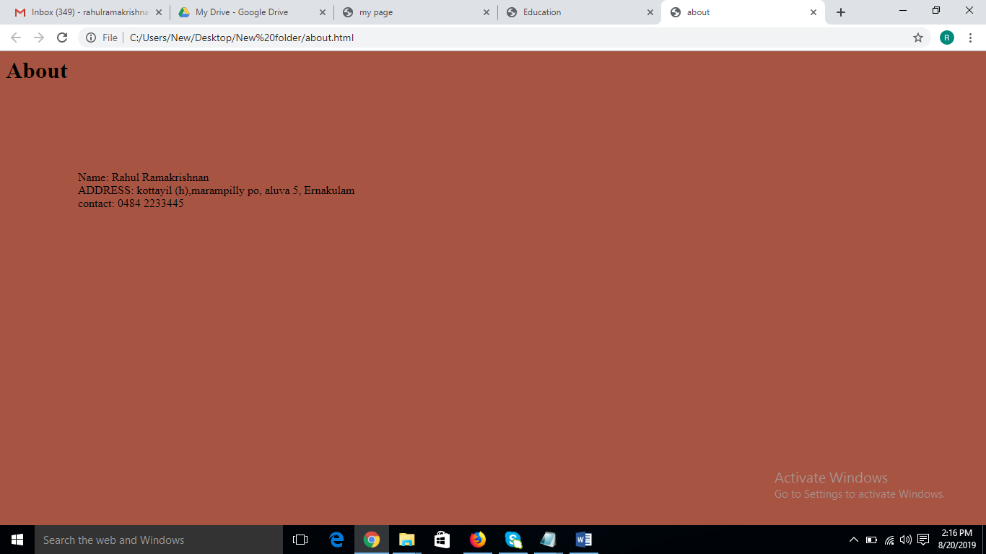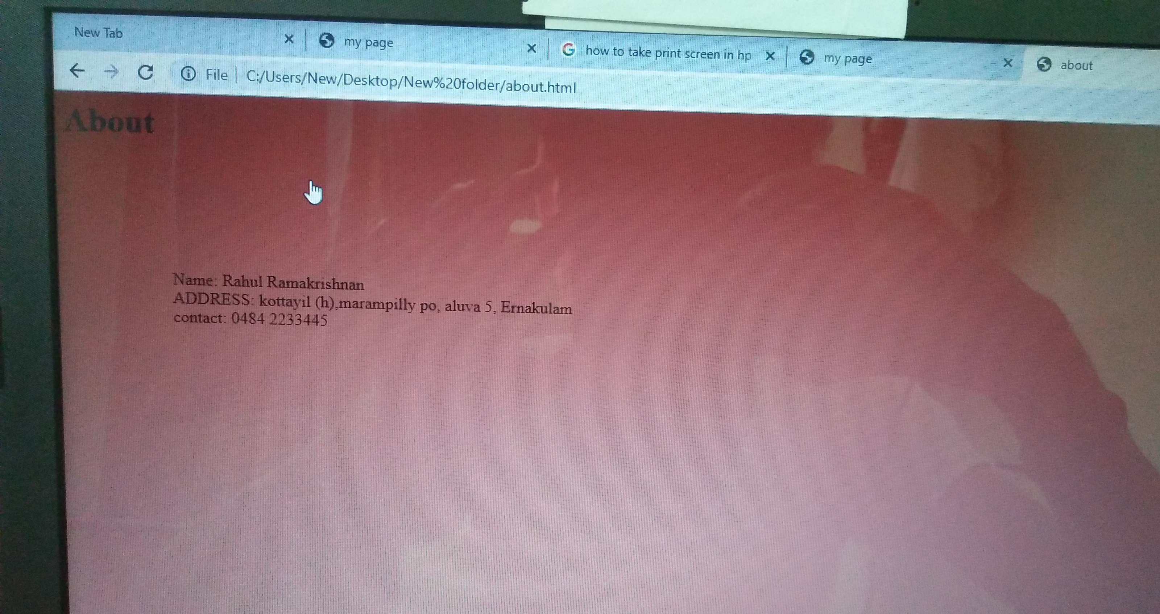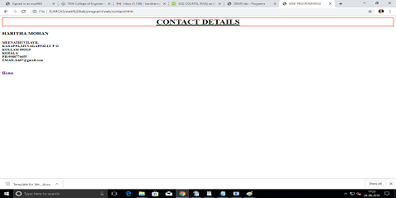

## Figure 3: About Details